Resource Teachers:
Learning and Behaviour (RTLB)
Policy and Toolkit
(2007)

RTLB Rollout Meetings

Table of Contents

Document Overview 1
Foreword 1
How to Use this Document 3
Part 1: Policy Framework 4
Chapter 1: RTLB Introduction 5
Overview 5
Why have the RTLB Service? 6
Providing Support 7
Chapter 2: RTLB Policy 10
Overview 10
Ministry of Education RTLB Policy 11
Cluster Governance 13
Cluster Management 14
Cluster Staffing 16
Evidence of Effective Clusters 18
Evidence-Based Student Outcomes 19
Part 2: Governance and Management Toolkit 21
Chapter 3: Cluster Management 22
Overview 22
Principal Induction 23
Memorandum of Agreement 25
Cluster Operational Document 26
Management Committee 28
Ministry of Education Support for Clusters 31
Help from Other Agencies 33
Support for Māori 34
Chapter 4: Staff Management 36
Overview 36
Employer School Responsibility 37
RTLB Appointments 39
Professional Learning and Induction 43
Conditions of Service 45
Chapter 5: Staff Performance Management 46
Overview 46
Performance Appraisal Overview 47
Performance Appraisal Cycle 49
RTLB Professional Standards Overview 51
1. Professional Knowledge Standard 52
2. Professional Leadership Standard 53
3. Professional Development Standard 54
4. Te Reo Me Ona Tikanga Standard 55
5. Teaching Techniques Standard 56
6. Staff and Student Management Standard 57
7. Relationship Management Standard 58
8. Programme Management Standard 59
Chapter 6: Funding and Administration 60
Overview 60
Manage Funding 61
Grants and Allowances 62
Travel Management 64
Sick Leave Reliever Funding 66
Learning Support Funding 67
Chapter 7: Planning and Reporting 70
Overview 70
Planning and Reporting Cycle 71
Record Keeping and Reporting 73
Chapter 8: Professional Practice 74
Overview 74
Professional Practice Overview 75
Support 77
RTLB/GSE Interface 78
Professional Supervision 79
NZRTLBA and Learning Support Networks 82
Induction and Coaching 83
Te Kete Ipurangi and Reading and Research 84
RTLB Qualification 86
Communities of Practice 89
Conference and Hui 90
In-service Teacher Education Practice (INSTEP) 91
Chapter 9: Service Provision 92
Overview 92
Access to Service 93
Eligibility for Service 94
Referral and Review 97
Intervention Sequence 100
Recording and Reporting 101
Safe Practice 103
Confidentiality 104
Acknowledgements 105

Document Overview

Foreword

Background | Resource Teacher: Learning and Behaviour (RTLB) positions were introduced in 1999 as part of the Special Education Policy initiatives of that time.  The intent of Special Education Policy is that all students who require specialist services and teacher support receive them. Support and resources are prioritised to those students with the highest needs. RTLB have a pivotal role to play in assisting cluster schools to meet the needs of their students with learning or behaviour difficulties.

Key to success | It is essential that all services work together to ensure that those students who have a learning or behaviour need receive appropriate support.

Reasons for this document | The Evaluation of the Resource Teacher: Learning and Behaviour Service (2004) conducted by the Education Review Office showed that there were some clusters that were operating effectively and that this led to positive outcomes for students.  The evaluation also showed that there were a significant number of clusters that could not provide evidence of positive outcomes in governance, management and professional practice. Accordingly, the Ministry of Education has, with strong support from education sector organisations, replaced the previous document (ie the obsolete document below) with this document.

Obsolete document | The Resource Teachers: Learning and Behaviour (RTLB) Clusters Effective Governance, Management and Practice (2001) is obsolete.

What this document provides | This Resource Teachers: Learning and Behaviour (RTLB) Policy and Toolkit  (2007) provides the policy for RTLB to which all clusters must adhere.  This document also provides a toolkit of information and resources to support clusters in their governance, management and professional practice. The toolkit includes information about avenues of support for clusters. (Professional practice resources in the toolkit will be added to over time.)  RTLB and staff involved in cluster governance and management will find this RTLB Policy and Toolkit to be an essential tool for continuous improvement of RTLB service.
Continued on next page
Foreword, Continued

How this document was developed | Development of this document has been a collaborative effort, involving support and input from the major education organisations as outlined below.  - Members of each organisation have participated in project teams that have developed the content.  - Extensive consultation has enabled many principals and teachers to make a positive contribution to the document.  - A sector reference group has effectively monitored the progress of the project.  A list of Acknowledgements is on page 104.

Karen Sewell
Secretary for Education

How to Use this Document

Introduction | The purpose of this document is to provide direction to schools who use the RTLB service in terms of:  - policy to follow (what needs to happen)  - tools to use (how to do it).  Note: The templates referred to do not form part of this document, but should be used in conjunction with it. To access these, refer to the Templates document, or downloaded them from www.tki.org.nz/r/governance/rtlb

Audience | The audience for this document includes:  - trustees  - principals  - RTLB  - Ministry of Education staff.  Trustees will primarily be concerned with Part 1: Policy Framework.  The other audience groups will need to refer to all parts of this document.

Cluster – key terminology | Key terminology used throughout this document is 'cluster'. A cluster is a designated geographical grouping of schools that determines its own governance and management structure within the RTLB policy framework and manages the cluster service.

Document Contents | This document contains the following parts:
  Part | See Page
  Part 1: Policy Framework | 4
  Part 2: Governance and Management Toolkit | 21

Part 1:
Policy Framework
Overview

Introduction | This part of the document outlines the Resource Teacher: Learning and Behaviour (RTLB) policy that must be followed by those providing the RTLB service.  This policy should be used in conjunction with Part 2: Governance and Management Toolkit, which provides supporting information and tools for RTLB clusters.

In this part | This part contains the following chapters:
  Chapters | See Page
  Chapter 1: RTLB Introduction | 5
  Chapter 2: RTLB Policy | 10

Chapter 1:
RTLB Introduction

Overview

Introduction | This chapter provides background to the RTLB service. It also explains the relationship between RTLB and other support providers and class and subject teachers.

In this chapter | This chapter contains the following topics:
  Topic | See Page
  Why have the RTLB Service? | 6
  Providing Support | 7

Why have the RTLB Service?

Goals of schooling | The goal of schooling is for all students to achieve their potential.  To achieve this goal, schools must ensure that:  - all students are taught effectively  - teaching practice benefits from assessment for learning and evidence of student outcomes.  Schools aim to improve social and academic outcomes for all students and encourage families and whānau to nurture children's learning.  The National Education Goals (NEGs) call for 'success in their learning for those with special needs by ensuring that they are identified and receive appropriate support'.

Students with special needs | The National Administration Guidelines (NAGs) require schools to identify students who are at risk of not achieving or who have special education needs. From this, schools must develop and implement strategies that address the identified needs. This means improving opportunities and outcomes for students currently underachieving across all dimensions of knowledge, skills, attitudes, values, and identity.

Why RTLB? | The RTLB service is one of the school-based resources supporting schools to meet these responsibilities.

Providing Support

What RTLB provides | RTLB provide itinerant specialist support to students and their teachers, in order to improve the educational outcomes for year 0–10 students with moderate learning or behaviour difficulties. Refer to the diagram below.

Part of a range of services | RTLB is part of a continuum of services that consists of:  - Ministry of Education Special Education (GSE) staff  - Learning Support Teachers (LST)  - RTLB  - other resource teachers  There are no rigid divisions between the various services. GSE, LST and RTLB work together so that all students needing support can receive it.  Class and subject teachers still have responsibility when students are receiving support through GSE, LST, and RTLB.

Support continuum | The diagram below illustrates the continuum of support available:  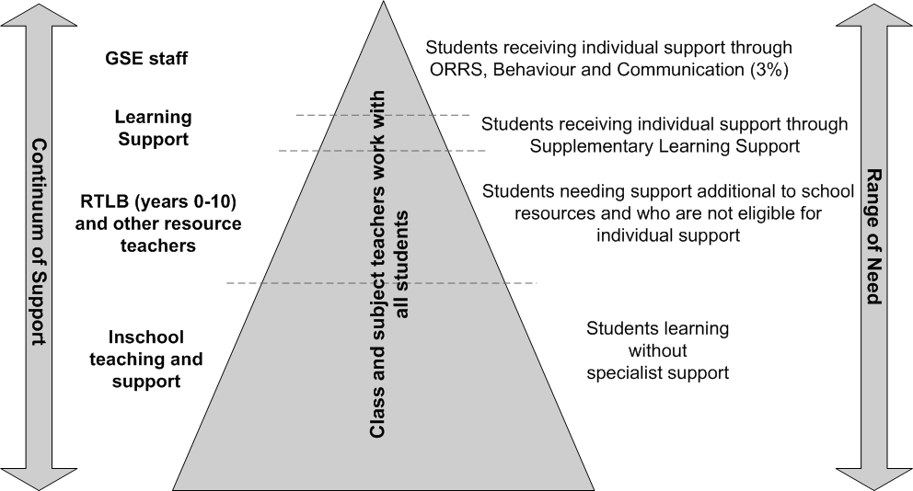  This diagram is explained on the following page.
Continued on next page
Providing Support, Continued

Support continuum explanation | The following points relate to the support continuum diagram on the previous page (working from the base of the triangle).  - The majority of students, who don’t have special needs, are supported by regular class and subject teachers.  - Students with learning and behaviour needs are supported first from school resources such as the special education grant.  - Students with learning and behaviour needs in years 0–10 who need support additional to school resources, and do not meet the criteria for the Ongoing and Reviewable Resourcing Schemes (ORRS), the Severe Behaviour Initiative, and Supplementary Learning Support, may be eligible for RTLB support.  - Students receiving individual support through Supplementary Learning Support are supported by LST.  - Students receiving individual support through the ORRS, Behaviour and Communication are supported by GSE staff.  - All students eligible for RTLB, LST, and GSE support remain the responsibility of class and subject teachers.

GSE and RTLB working together | The key difference between GSE and RTLB support is:  - GSE focuses on the students with the 'highest' needs  - RTLB focuses on those students with 'moderate' needs.  However, students' needs are not adequately described by terms such as 'severe' or 'moderate' need. Students may have different levels of need at any one time or different levels of need over time.  It is vital that GSE and RTLB work together to ensure that students do not miss out on a service that they need.
Continued on next page
Providing Support, Continued

How the RTLB model works | RTLB work across a designated geographical cluster of schools and each is employed by a school board within the cluster.  Schools may access the RTLB service to ensure that their students with learning or behaviour difficulties:  - are supported appropriately  - have programmes that cater for their diverse needs and learning goals  - have their curriculum adapted in a way that is as inclusive and unobtrusive as possible  - are taught by class and subject teachers skilled in teaching practices known to be helpful for diverse groups of students.

Advantages of RTLB | Effective RTLB support is likely to provide a school with systems and practices that:  - maintain an educational focus in inclusive classroom environments  - adapt the curriculum to meet the needs of diverse learners  - achieve positive, measurable outcomes for all students, including those with learning and behaviour difficulties.  The intent of special education policy is that all students who require specialist services and teacher support receive them as early as possible and that students with the greatest needs have the highest priority.

Chapter 2:
RTLB Policy

Overview

Introduction | This chapter outlines the policy that must be followed by Resource Teacher: Learning and Behaviour (RTLB) clusters.  Part 2: Governance and Management Toolkit provides further detail and supporting information and tools for RTLB clusters.

In this chapter | This chapter contains the following topics:
  Topic | See Page
  Ministry of Education RTLB Policy | 11
  Cluster Governance | 13
  Cluster Management | 14
  Cluster Staffing | 16
  Evidence of Effective Clusters | 18
  Evidence-Based Student Outcomes | 19

Ministry of Education RTLB Policy

Introduction | All schools and clusters must adhere to Ministry of Education RTLB policy.  The RTLB policy consists of the 12 parts outlined in this topic.

Teachers | RTLB are full-time, permanent, itinerant teachers. They work in designated clusters of state and state-integrated schools. They provide support for year  0–10 students who have moderate learning or behaviour difficulties.

Trustees | An RTLB is employed by a board of trustees within a cluster. The employing board has all of the employer responsibilities.

RTLB qualification | Every RTLB must attain the RTLB qualification within three years of appointment. This is mandatory and the Ministry of Education does not grant exemptions. Training providers will recognise prior learning in accordance with their institutions' rules (refer to page 85 for detail).

Governance | Every cluster has:  - a governance group  - a management committee  - a fund-holder school  - at least one employer school  - a cluster principal as a convenor.

Memorandum of Agreement | Every cluster has a Memorandum of Agreement that describes the roles and responsibilities of the schools in the cluster and the relationship between the cluster and the Ministry of Education.

Operational Document | Every cluster has an Operational Document of policies and procedures that align with RTLB policy. The Operational Document includes an equitable, transparent, referral system that ensures referrals go to RTLB, Ministry of Education Special Education (GSE), or elsewhere as appropriate.

Cluster resourcing | Every cluster has equitable and transparent processes for using its staffing and funding resourcing to achieve positive student outcomes.

Secondary schools | Clusters with secondary schools acknowledge their different and complex structures and provide support accordingly.
Continued on next page
Ministry of Education RTLB Policy, Continued

Work collaboratively | Schools, RTLB and GSE work collaboratively to ensure all students who need specialist support receive it.

Evidence-based practice | RTLB provide a consistent professional standard of evidence-based practice to support schools to improve outcomes for students.

Intervention goals | Goals for RTLB interventions are culturally appropriate and fall within the following four domains:  - participation  - social/behavioural  - learning achievement  - teacher/school capability

Cluster planning and reporting | Every cluster must:  - plan annually to meet the needs of the target students, including those in Māori-medium settings  - ensure every RTLB keeps a record of work undertaken with students and the outcomes  - collate the records of individual RTLB into a cluster record  - report annually on the work of their RTLB and the outcomes of students, to all schools in the cluster and in a prescribed format to the Ministry of Education.

Where to from here | More detail about RTLB policy is provided in the remainder of this part of the document in the following topics:  Part 2 of this document provides the supporting toolkit.
  Topic | See Page
  Cluster Governance | 13
  Cluster Management | 14
  Cluster Staffing | 16
  Evidence of Effective Clusters | 18
  Evidence-Based Student Outcomes | 19

Cluster Governance

Introduction | Just as boards of trustees are responsible for the governance of their schools, so are the boards of the cluster schools collectively responsible for the governance of the RTLB cluster. Boards may formally delegate this responsibility to the cluster principals.  Note: Ministry of Education staff are not members of the governance group.

Responsibilities | Clusters are responsible, within the RTLB policy, for their own governance and management. The Ministry is available for advice and support. Working within the RTLB policy framework, each cluster's governance group determines its governance and management structure and sets its own policies that govern the way the cluster and RTLB work.  Governance responsibilities include:  - being partners to a memorandum of agreement amongst all cluster schools and the Ministry  - nominating cluster employer school(s) with the intention of eventually reducing to one employing school in the cluster (see note below bullets)  - nominating one school board to receive and manage cluster funds: administration and travel grants, learning support funding (LSF), and year 11–13 funding (see note below bullets)  - ensuring the development of a cluster operational document that describes policies and procedures, including appointments  - approving the cluster operational document  - appointing one of the cluster principals as cluster convenor  - ensuring the operation of an appropriate needs-based referral system  - ensuring RTLB interventions focus on positive outcomes for identified students  - ensuring that the cluster carries out an annual cycle of planning, self-review and reporting  - ensuring annual reporting to cluster school boards and the Ministry of Education on the use of RTLB staffing, LSF, year 11–13 funding, and outcomes for referred students  - ensuring that new principals participate in relevant induction processes.  Note: The Ministry of Education must approve employer and fund-holder schools.

Cluster Management

Introduction | Managing the RTLB service within each cluster is shared by the employing and fund-holder schools and the cluster principals.  The key to effective cluster management is development of, and adherence to, the cluster's Memorandum of Agreement and the Operational Document.

Cluster management committee | Each cluster must have a management committee, which could be the cluster governance group. This management committee should include representatives of RTLB, principals and others according to cluster policy. The committee monitors and manages the RTLB service and provides advice and support to the employing principal(s). Ministry staff may attend meetings to provide advice.  Note: Ministry of Education staff are not members of the management committee.

Cluster convenor role | One of the cluster principals acts as cluster convenor. The convenor ensures:  - the management committee meets regularly  - there is good communication with the Ministry of Education  - there is good communication among the cluster's schools regarding all matters related to RTLB.

Referral and review committee | Clusters should operate a separate referral and review committee (also referred to as intake and review committee). This should comprise GSE and representatives of the cluster's RTLB and principals.

Memorandum of Agreement | Every cluster must have a Memorandum of Agreement that describes the roles and responsibilities of the schools in the cluster and the relationship between the cluster and the Ministry of Education.  If an RTLB Māori works across more than one cluster, each cluster should have a relevant addendum in its Memorandum of Agreement.
Continued on next page
Cluster Management, Continued

Operational Document | Each cluster must have an Operational Document that is in accordance with RTLB policy. It must describe how the cluster intends to meet the needs of referred students and to monitor the outcomes of RTLB interventions.  The Operational Document needs to include the following components:  - administration  - management  - cluster planning and reporting  - a protocol for professional collaboration with GSE  - use of cluster funds  - service provision, including referral processes.  The Operational Document is drafted by the management committee and approved by the cluster's governance group.

Cluster funding | Funding is provided to the cluster's fund-holder school. It must be managed in accordance with the cluster Operational Document. Use of cluster funding must be included as a separate item in the fund-holder school's annual report.

For more information | For more information about cluster management, refer to Part 2: Governance and Management Toolkit, in particular Chapter 3: Cluster Management on page 22.

Cluster Staffing

Introduction | Cluster staffing is based on a formula that reflects cluster schools' deciles and year 0–10 student rolls. Local factors such as remoteness and the number of schools in the cluster are also considered.

How staffing is reviewed | The Ministry of Education reviews cluster staffing annually. The review is based on the 1 July roll return and ensures that there is an equitable distribution of RTLB positions nationally. The staffing numbers are set according to Orders in Council and are based on a national formula of each school's year 0–10 student rolls, weighted by decile. Local factors, such as isolation or numbers of schools in a cluster, may be taken into account. The formula does not provide an 'entitlement'. It is used as the starting point for the distribution of positions.  To ensure an equitable, national distribution of positions, Ministry of Education approval is needed before a vacancy is filled.

RTLB position | The RTLB position is a full-time, permanent position and should not be split into part-time components.  RTLB must be New Zealand registered teachers with a current practising certificate.  An RTLB, on appointment, must:  - be able to itinerate among cluster schools  - have the capability and capacity to attain the RTLB qualification  - be able to meet the Interim Experienced Teacher Professional Standards in the relevant teachers' collective agreements.

RLTB Māori | As part of their annual review, clusters must consider the needs of Māori students, especially those in Māori-medium settings.  This may mean that the cluster, in agreement with the Ministry, designates an existing position RTLB Māori. Alternatively, the cluster may appoint an RTLB with appropriate skills to an existing position not designated RTLB Māori, or may contract in expertise. In a few cases, an RTLB Māori may be asked to work across more than one cluster.  The priority for RTLB Māori, where designated, is to work in Māori-medium settings. Any remaining time is used in mainstream settings.
Continued on next page
Cluster Staffing, Continued

Secondary schools | Secondary schools have complex structures that are different from those of primary schools. Therefore they may have a dedicated RTLB either full or part-time. This allows the RTLB to develop appropriate relationships with pastoral care staff, years 9 and 10 deans, and senior management, within the secondary environment. Employment must be flexible enough to allow for work in the school at different times during a week.

Board of trustees and principal management | The employing board of trustees has all the employer responsibilities for individual RTLB. These include appointment and performance management, including professional supervision and appraisal. Usually, the board delegates these responsibilities to the principal, who may in turn delegate them further.

For more information | For more information about cluster staffing, refer to Part 2, Governance and Management Toolkit, in particular Chapter 4: Staff Management on page 36.

Evidence of Effective Clusters

Introduction | It is essential that RTLB clusters are effective in line with RTLB policy.

How to determine if a cluster is effective | An effective RTLB cluster will be able to show evidence that it:  - operates in accordance with RTLB policy  - focuses on positive outcomes for all students  - is able to demonstrate the outcomes of RTLB interventions  - has clear referral processes that ensure equitable access for all students with learning or behaviour difficulties  - has RTLB that work collaboratively with GSE to provide a seamless continuum of flexible service for students with learning or behaviour difficulties  - has quality systems for RTLB appointment and performance management, including professional supervision and appraisal  - has a robust planning and reporting cycle incorporating self-review  - encourages continuing professional learning to improve practice and ensures a diverse RTLB skill base  - values collegial support and provides mentoring when needed  - maintains professional, trusting, respectful relationships at all levels  - communicates with clarity and openness  - has a cluster Operational Document of policies and procedures  - has strong professional leadership in governance and management and the active participation of cluster principals, who have a shared understanding of the RTLB role  - has transparent processes for allocation of funding on a needs basis in accordance with Ministry of Education and cluster policy.

Evidence-Based Student Outcomes

Introduction | RTLB need to gather sufficient evidence to show their interventions are effective. They collect, analyse and use data during their involvement with students or group of students and their teachers, in relation to mutually agreed goals. Teachers and RTLB, at all times, work in ways that strengthen the culture and self identity of all students.  The goals set by RTLB and teachers for each student, or group of students, are in the domain of participation, social/behavioural, learning achievement, and teacher/school capabilities. These are outlined in this topic.

Participation | Examples of participation goals are:  - improved attendance and punctuality  - increased time in class  - preparedness to learn  - engagement in classroom activities  - contribution  - increase in on-task behaviour  - improved work habits.

Social/ behavioural | Examples of social/behavioural goals are:  - improved relationships with teachers/peers  - cooperative skills  - conflict resolution and communication skills  - increase in appropriate behaviours in class and playground.

Learning achievement | Examples of learning achievement goals are:  - gains in literacy, numeracy and other curriculum areas  - improved skills and knowledge  - greater work output  - enhanced thinking and decision making skills.

Teacher/school capability | Examples of teacher/school capability goals are:  - increased teacher knowledge/skills relating to diverse learners  - enhanced teacher effectiveness  - school systems that support improved outcomes for students with learning or behaviour difficulties.
Continued on next page
Evidence-Based Student Outcomes, Continued

For more information | For more information about measuring shifts in learning and behaviour and gathering evidence, refer to the Recording and Reporting topic on page 100 of Chapter 9: Service Provision.

Part 2:
Governance and Management Toolkit
Overview

Before you use this part | Before you use this part of the document you must be familiar with Part 1: Policy Framework.

Purpose of toolkit | Effective practice depends on having quality governance and management systems and processes.  This part of the document provides guidance on how to implement the RTLB policy outlined in Part 1. It provides information and resources to support clusters in their governance, management and professional practice. It also includes information about additional avenues of support for clusters.  Professional practice resources in this toolkit will be added to over time.  Advice and guidance on governance and management are available from Ministry of Education National Operations staff. Advice on professional practice matters is available from Ministry of Education Special Education (GSE) staff.

Templates | This toolkit is to be used in conjunction with the Templates document, which has forms and other templates for photocopying. The forms and other templates can also be downloaded from www.tki.org.nz/r/governance/rtlb/.

In this part | This part contains the following chapters:
  Chapters | See Page
  Chapter 3: Cluster Management | 22
  Chapter 4: Staff Management | 36
  Chapter 5: Staff Performance Management | 46
  Chapter 6: Funding and Administration | 60
  Chapter 7: Planning and Reporting | 70
  Chapter 8: Professional Practice | 74
  Chapter 9: Service Provision | 91

Chapter 3:
Cluster Management

Overview

Before you begin | Ensure you are familiar with Part 1, Chapter 2 RTLB Policy on page 10.

In this chapter | This chapter contains the following topics:
  Topic | See Page
  Principal Induction | 23
  Memorandum of Agreement | 25
  Cluster Operational Document | 26
  Management Committee | 28
  Ministry of Education Support for Clusters | 31
  Help from Other Agencies | 33
  Support for Māori | 34

Principal Induction

Introduction | All principals, particularly those who are new to a cluster, or new to the role of employing an RTLB, will benefit from an induction focused on the cluster's RTLB service. The induction should be overseen by the principal's board and the cluster's governance group.  Induction involves other principals in the cluster, RTLB, and local Ministry of Education staff (who should be notified of the new principal's appointment by the cluster convenor).  Note: There may be other teachers within the cluster who would benefit from a similar induction process. For example, year 9 and 10 deans, Special Education Needs Coordinators (SENCOs), and other teachers with responsibility for special needs.

Components of induction | Induction should include the following components:  - the RTLB role, and the target group of students, including those in Māori-medium settings  - familiarisation with the RTLB Policy and Toolkit (this document)  - familiarisation with cluster operational documents, cluster planning and reporting documents and the cluster protocol with GSE  - how to distinguish between usual school policy and RTLB policy, particularly regarding cluster schools' differing expectations and policies  - how RTLB grants and budget are managed  - information about the professional needs of RTLB staff  - information about Ministry of Education requirements, including reporting  - an overview of the RTLB training course, its purpose, content and format.

Opportunities provided by induction | Induction for new employing principals should provide opportunities to:  - discuss RTLB matters with board of trustees  - meet with local Ministry of Education staff responsible for RTLB  - discuss issues with experienced principals who employ RTLB  - share experiences with other new RTLB employer principals  - recognise iwi partnerships  - talk with cluster RTLB staff  - access RTLB website Frequently Asked Questions (FAQ)  - participate in NZ Principals' Leadership Centre's Principal Professional Learning Communities (PPLC).

Memorandum of Agreement

Introduction | Every cluster must have a Memorandum of Agreement that describes the roles and responsibilities of the schools in the cluster, and the relationship between the cluster and the Ministry of Education.  The Governance Group of each cluster is responsible for that cluster's Memorandum of Agreement.

Purpose | The purpose of the Memorandum of Agreement is to record the agreement between the:  - boards of the schools within a cluster  - cluster and the Ministry of Education.  This agreement relates to roles and responsibilities of RTLB allocated to the cluster and the resourcing of those teachers.

Template and key points | The Memorandum of Agreement needs to include:  - the term of the agreement  - the make up of the cluster governance group  - employer school responsibilities  - fund-holder school responsibilities  - Ministry of Education responsibilities  - how reporting will occur  - how disagreements will be handled  - how lodging, amendments and cancellation of the memorandum will occur.  The Memorandum of Agreement template is contained in the Templates document and can be downloaded from www.tki.org.nz/r/governance/rtlb/.

Cluster Operational Document

Introduction | Each cluster must have an Operational Document that describes cluster policies and procedures, in accordance with RTLB policy. The cluster management committee (refer to page 28) is responsible for development of the Operational Document.

Teachers' collective agreements | The Operational Document must refer to the relevant teachers' collective agreements.

Components summary | There is no specific template for the Operational Document. Clusters can determine their own formats. However, a cluster Operational Document needs to include the following components:  - management  - administration  - professional and employment  - planning and reporting  - service provision.  These components are described in the remainder of this topic.

Management | The Management component needs to cover:  - governance group  - management committee  - Māori students  - employer school responsibilities  - meeting protocols  - cluster communications  - cluster policy development and review.

Administration | The Administration component needs to cover:  - financial management  - cluster resourcing  - travel management  - insurance.
Continued on next page
Cluster Operational Document, Continued

Professional and employment | The Professional and Employment component needs to cover:  - vacancies and appointments  - job description/s  - induction  - performance management  - professional supervision  - professional learning  - safe practice  - confidentiality and information  - conditions of service.

Planning and reporting | The Planning and Reporting component needs to include:  - planning and reporting cycle  - cluster needs analysis  - reporting to the cluster  - reporting to the Ministry of Education.

Service provision | The Service Provision component needs to include:  - access to RTLB Support  - referral (intake) and review  - managing transitions  - intervention sequence  - recording and reporting outcomes  - protocol with Ministry of Education Special Education (GSE)  - Ministry of Education support for clusters  - help from other agencies.

Management Committee

Introduction | Each cluster has a management committee that comprises (at minimum):  - the employing principal(s) and fund-holder principal  - representatives of other cluster schools  - representatives of the cluster's RTLB  - Māori and Pacific Island representation (wherever possible)  - a principal as cluster convenor.

RTLB role management responsibilities | The management committee must ensure it meets the RTLB role management responsibilities outlined below.  - Keep the boards of trustees, staff of cluster schools and parents, families and whānau well informed about the role and work of RTLB.  - Ensure the principles of RTLB practice are understood and supported by all cluster schools.  - Have a process for notifying notify the local Ministry of Education office of any cluster vacancies and for requesting approval to advertise.  - Advise on appointments of RTLB.  - Support employing principals in providing appropriate professional learning and support for RTLB, including professional supervision.  - Work with the employing school board(s) in supporting RTLB to attain the RTLB qualification. This may include providing a reduced case load, access to the agreed study leave, and (if necessary) access to an academic mentor.

Services provision responsibilities | The management committee’s service provision responsibilities are outlined below.  - Negotiate a protocol for GSE and RTLB to work cooperatively in supporting students, especially at referral stage and during transitions.  - Manage needs-based access and referral processes in accordance with the cluster's policies.  - Make RTLB services available to all schools within the cluster. There should be no 'capture' by a single school, except when the cluster agrees that an RTLB be dedicated (part-time or full-time) to a secondary school.
Continued on next page
Management Committee, Continued

Operational responsibilities | The management committee’s operational responsibilities include developing and updating the Operational Document that describes cluster policies and procedures.  The management committee also needs to review and monitor operational procedures for RTLB to ensure they are consistent with the agreed cluster policies.

Policy development and review | As with school policies and procedures, each cluster should implement a cycle of policy development and review.

Planning and reporting responsibilities | The management committee needs to lead the annual cluster planning, self-review and reporting cycle.  It is responsible for presenting an annual report to the cluster committee and an annual report (in the agreed format) to the Ministry of Education.  The management committee needs to report regularly to the cluster governance group, advising on:  - distribution of duties  - deployment of the RTLB among the cluster  - RTLB rolls  - outcomes for students.

Budgeting and financial management responsibilities | The management committee’s budgeting and financial management responsibilities are outlined below.  - Ensure that the cluster's financial policies are followed by the fund-holder and employer school(s).  - Establish and monitor the budget on the cluster's behalf.  - Process RTLB reimbursement claims for expenses associated with:  - travel (at approved collective agreement rate)  - stationery  - professional development  - other items within the budget guidelines from the fund-holder school.
Continued on next page
Management Committee, Continued

Cluster convenor responsibilities | The cluster convenor is responsible for ensuring:  - the management committee meets regularly  - good communication with the Ministry of Education occurs  - new principals participate in an induction process (refer to page 23)  - good communication occurs among the cluster's schools regarding all matters related to RTLB.

Meeting protocols | Clusters should have a policy statement about committee and subcommittee composition and meeting protocols, including chairing, regularity, and agenda.

Communicate | Many clusters have developed effective lines of internal communication, using, for example, newsletters, and monthly or term reports from RTLB to the management committee. Other clusters have an RTLB with a liaison role for nominated schools. Although RTLB work across the cluster on a needs basis, they visit their liaison school(s) regularly to provide informal support and advice. In these clusters, the RTLB liaison role is usually specified in the RTLB performance agreement.  The Ministry of Education's first point of contact with a cluster will usually be the cluster convenor.

Ministry of Education Support for Clusters

Introduction | At times clusters may encounter challenges that they are unable to resolve themselves. Ministry of Education staff are available to provide support to these clusters.

Support may involve… | Direct Ministry of Education support may involve:  - discussions  - advice for developing procedures and processes  - support and advice with professional practice  - professional supervision by GSE staff  - financial advice and guidance  - statutory interventions.

Types of problems | Problems will be identified by one of the following:  - annual report to the Ministry of Education  - Ministry of Education financial advisors  - regular discussion with the Ministry of Education  - cluster self identification (from cluster meetings or from the annual report to the cluster).  How the problem is dealt with depends on whether it is:  - industrial  - professional practice  - governance or maintenance.  The diagram on the next page illustrates possible avenues of support for clusters.
Continued on next page
Ministry of Education Support for Clusters, Continued

Support process | 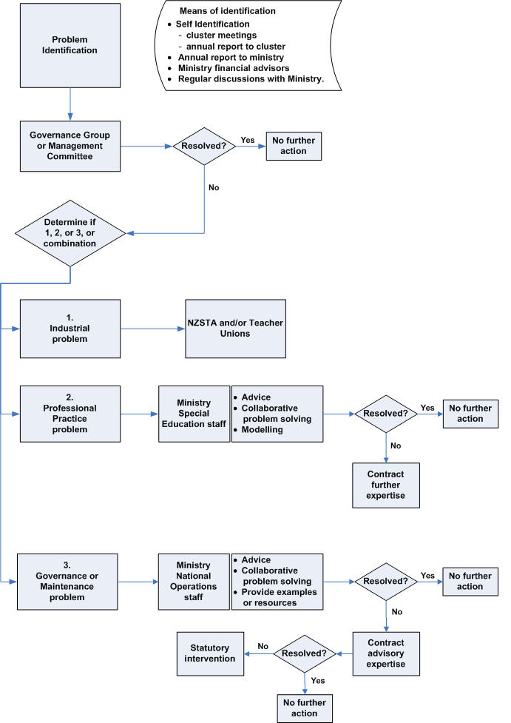

Help from Other Agencies

Introduction | Competency issues, leave provisions and other employment matters are covered in:  - collective agreements  - performance management policies  - complaints procedures  - the employer board's school policies  - cluster operational policies and procedures.

How to get help | If an industrial difficulty occurs between an RTLB and the management of the employer school, the chairperson of the school's board of trustees and/or the cluster convenor should be consulted.  If the difficulties are unresolved, refer to the Employment Relationship Problem Resolution section in the relevant collective agreement for services available.  Contact may also be made with New Zealand School Trustees' Association, New Zealand Educational Institute or Post-Primary Teachers' Association field officers.

Support for Māori

Introduction | All RTLB may take referrals for Māori students. In some clusters one or more positions may be designated RTLB Māori, to focus specifically on Māori students.  When 'regular' RTLB vacancies occur, clusters have an opportunity to consider their specific needs. A cluster may negotiate with the Ministry of Education to designate a vacant 'regular' RTLB position as an RTLB 'Māori' position.  Note: Clusters may not unilaterally change the designation of an RTLB position.

RLTB Māori role | An RTLB Māori has the same role as other RTLB, but works primarily to support students in Level 1 and 2 Māori-medium settings. Any remaining time is used to support mainstream schools and classes. There should be clear and agreed expectations about how the workload of each RTLB Māori will be managed.

Māori management subcommittee | The cluster management committee carries out all the regular functions, except when the governance group decides (in collaboration with neighbouring clusters) that an RTLB Māori will operate across more than one cluster.  If an RTLB Māori works across clusters, a separate Māori management subcommittee may be established with representatives from:  - the governance group of each of the clusters served  - designated kura, schools, and/or schools with Māori-medium classes  - iwi and/or runanga  - RTLB Māori.  This subcommittee monitors and supports the day-to-day work of the RTLB Māori across the clusters, but the RTLB Māori remains accountable to the employing school.

Impact on Memorandum of Agreement | If an RTLB Māori works across clusters, there should be an addendum to each cluster's Memorandum of Agreement.
Continued on next page
Support for Māori, Continued

Impact on funding | If an RTLB Māori works in more than one cluster, the Ministry may fund travel at a higher rate. However, clusters will have to agree about sharing any other costs incurred; for example, resource provision.  If more than one cluster shares an RTLB Māori, access to each cluster's Learning Support Funding must be ensured.  Arrangements regarding cross-cluster work should be reviewed on an agreed timeframe, as changes to rolls within clusters may mean changes in the cross-cluster work.

Chapter 4:
Staff Management

Overview

Before you begin | This chapter covers the responsibilities of the school as the employer of an RTLB, how appointments are made, and how new RTLB are inducted into clusters and into their roles.  Ensure you are familiar with Chapter 2: RTLB Policy, in particular the topic about Cluster Staffing on page 16.

In this chapter | This chapter contains the following topics:
  Topic | See Page
  Employer School Responsibility | 37
  RTLB Appointments | 39
  Professional Learning and Induction | 43
  Conditions of Service | 43

Employer School Responsibility

Introduction | Although an RTLB has to serve all the schools in the cluster equitably, the employer school board still has all the employment responsibilities for RTLB.  The following are the responsibilities of the employing board, through the principal.

Appoint suitable applicants | Principals need to use evidence of cluster needs to identify the skills required in an RTLB. They should ensure that only suitable applicants are appointed to vacant RTLB positions. For more on this, refer to page 39.  All those appointed must be experienced, credible teachers who can meet the Interim Experienced Teacher Standards and who have the capacity and capability to attain the RTLB qualification. For more on this, refer to the RTLB Qualification topic on page 85 of Chapter 8: Professional Practice.

ESP1 and 2007/A1 forms | When they make appointments, principals must advise the Education Services Payroll via the ESP1 form. They must also send a copy of this form with the RTLB 2007/A1 form to the local Student Support Team of the Ministry.  Form 2007/A1 is in the Templates document and is available from www.tki.org.nz/r/governance/rtlb/.

Job description | Principals should use the national job description for the RTLB role, adding skills according to the cluster needs analysis. Preferably the appointee should sign the job description, indicating acceptance. The job description is in the Templates document or can be downloaded from www.tki.org.nz/r/governance/rtlb/. There is a separate job description for RTLB Māori.

Performance management | Principals should implement the performance management process. This should include a robust performance appraisal process, with reference to agreed cluster policies. They should also have an annually negotiated performance agreement for each RTLB.  For more on this, refer to Chapter 5, Staff Performance Management on page 46.

Arrange supervision | Principals should provide appropriate professional supervision. For more on this, refer to the Professional Supervision topic on page 79 of Chapter 8: Professional Practice.
Continued on next page
Employer School Responsibility, Continued

Support training | Principals should help RTLB attain the RTLB qualification. They should provide access to agreed study leave, a reduced caseload and, if necessary, an academic mentor/coach. The RTLB should attain the qualification within three years of appointment. For more on this, refer to the RTLB Qualification topic on page 85 of Chapter 8: Professional Practice.

Policies and processes | Principals should ensure that the policies of the school are understood and observed and that the RTLB follows agreed processes.

Facilities | Principals should provide RTLB with adequate office facilities. They should ensure that they are based in locations that foster collaborative and consultative interactions among the RTLB team.

RTLB Appointments

Introduction | It is important that clusters do not compromise the quality of an appointment in order to fill the vacancy quickly. It is better to wait until the right person for the RTLB position is found. Appointees must be credible 'teachers of teachers' and be able to attain the mandatory RTLB qualification. With Ministry approval, interim long-term relievers may be used in a vacant RTLB position.

Part-time or job-share | The RTLB position is permanent and full-time and may not be split up and shared among cluster schools as a series of part-time positions.  RTLB may be employed by either primary or secondary school boards under the relevant collective agreement, or on an individual employment agreement. The teachers' collective agreements allow for job-sharing of permanent positions. In such cases, the Ministry provides RTLB training for one teacher and it is the cluster's responsibility to provide training and study leave for the second teacher. It is not possible to carry out the requirements of the RTLB policy in a job share arrangement of less than a 0.4 FTE position.

Key points about appointments | When a cluster has a vacancy, the employing principal should advise the management committee. The committee determines whether the current employer school should continue or whether another school should take over this responsibility, keeping in mind that the long term goal is to have as few employers per cluster as practicable. The cluster convenor should notify the local Ministry National Operations staff the agreed employer school of the vacancy and seek approval to fill the vacancy.  Once the Ministry has given its approval, the management committee should consult with cluster schools and ensure the following occurs.  - A cluster needs analysis is conducted, so that the appointment process takes account of the needs of the cluster in relation to the RTLB skills already in the cluster. There may be schools with high proportions of Māori and Pasifika students with special needs. There may also be bilingual or immersion Māori or Pasifika programmes or kura kaupapa Māori that need to access an RTLB with special language strengths.  - Appropriate consultation occurs with parents, families, whānau and the wider cluster community. This is particularly important when filling an RTLB Māori or other cluster-designated position.  - The RTLB job description is reviewed, including the person specification. The appointee must be an experienced trained teacher registered in New Zealand who has a current practising certificate and is able to meet the Interim Experienced Teacher Standards.  Note: An untrained RTLB is required to attain the mandatory RTLB qualification, and may need to travel away for courses from time to time.
Continued on next page
RTLB Appointments, Continued

Appointment process diagram | The diagram below outlines the RTLB appointment process:  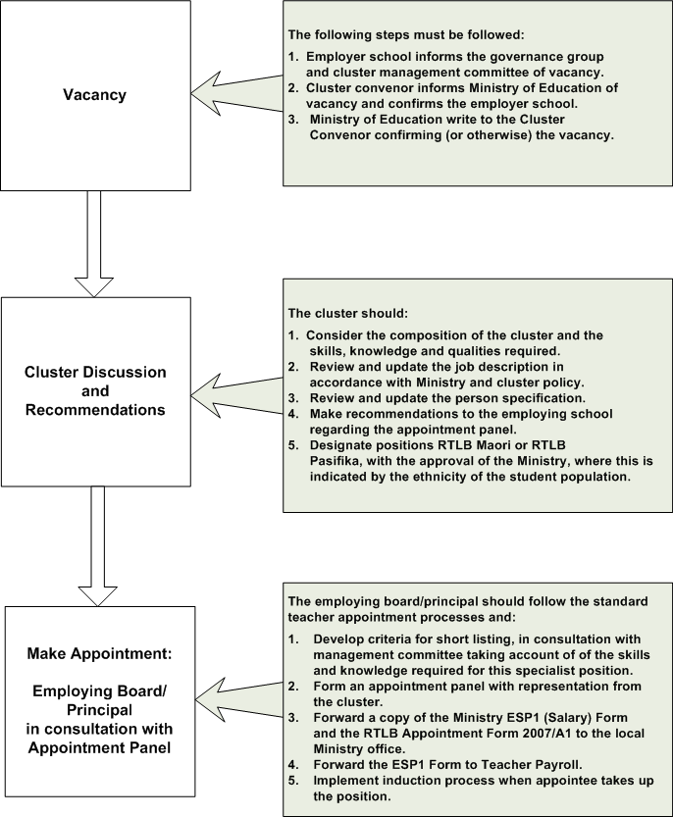

Job description | The national job description template for RTLB is in the Templates document an available from www.tki.org.nz/r/governance/rtlb/). Although the roles for mainstream and RTLB Māori positions are essentially the same, the contexts are differentiated through separate job descriptions. Clusters may wish to add items relevant to cluster needs.  Note: Because the job description is based on Ministry RTLB Policy, clusters should not delete items.
Continued on next page
RTLB Appointments, Continued

Resourcing and training for new appointees | Employing principals should photocopy the ESP1 form and attach the RTLB Form 2007/A1. These can be found in the Templates document and at www.tki.org.nz/r/governance/rtlb/)  Both forms should be sent to the local Ministry National Operations staff. This will ensure that clusters receive the appropriate resourcing and assist the Ministry to keep its database current. It will also ensure that training is arranged for those who need it. A National Operations Development Officer will contact the training provider following the lodging of the forms.

Contract must include RTLB qualification | Employing principals must ensure that the letter offering appointment includes a provision requiring the appointee to attain the RTLB qualification within three years of appointment.

Professional Learning and Induction

Professional learning | RTLB should have regular opportunities to engage in evidence-based professional learning that is tailored to their role.  Professional learning needs to be:  - planned and based on identified needs and performance management  - both formal and informal  - funded at cluster level through RTLB administration grants  - evidence-based  - responsive to identified RTLB and cluster needs  - linked to national curriculum initiatives and Ministry priorities  - led by credible facilitators who are familiar with the RTLB role and the New Zealand school context.

Induction | As part of the cluster's Operational Document there should be an induction section detailing process and responsibilities. The employing board is responsible for ensuring that induction is provided to newly appointed RTLB. Time should be allowed for induction on appointment and prior to the allocation of case work.  Effective induction processes, tailored to individual needs, will provide a smooth, safe and supported transition into the RTLB role.  There are two levels of induction:  - for those who are new to the cluster, induction into the cluster  - for those appointees who are new to the role, induction into the RTLB service.

Induction to cluster | For RTLB who are new to the service, or are trained and experienced but new to the cluster:  - assign a buddy or mentor to carry out/lead the induction process  - arrange for the buddy to introduce the new RTLB to cluster schools  - provide time for the new appointee to read, discuss and learn about the cluster and cluster schools' policies, procedures and preferences.
Continued on next page
Professional Learning and Induction, Continued

Induction to role | For appointees who have not previously been employed as RTLB, all of the above should be included in the induction, plus the following:  - Information about the RTLB role and the principles under which it operates. This needs to occur before the RLTB accepts referrals.  - RTLB guidelines and processes.  - Opportunity to co-work on a case with a more experienced RTLB or with a GSE specialist.  - Information about the New Zealand Resource Teacher: Learning and Behaviour Association (NZRTLBA).  - Access to an academic mentor, if necessary, to support the appointee during the study period.  New appointees also need an understanding of, and respect for, Māori world views. Therefore, induction must cover this.

Conditions of Service

Salary | RTLB salaries are centrally funded. Individual's details should be forwarded to the Ministry's education services payroll agents. RTLB are not part of the employer school's entitlement staffing. For this reason, they are shown on staffing notices as 'Additional Staffing'.  RTLB are placed on the base scale for primary or secondary teachers according to their qualifications and previous experience. They are allocated a permanent unit that is assigned to the RTLB position. This unit may not be allocated to any other teacher.  RTLB may progress to the maximum salary step regardless of their qualification level. They cannot go to the top of the salary scale on appointment. For more information, refer to the collective agreements for primary and secondary teachers.

Collective agreements | RTLB are employed either under the collective agreement relating to their employer schools or on individual employment agreements. This does not preclude them from working across sectors, depending on the makeup of the cluster.  RTLB work to the school terms and vacations of their employer schools, unless alternative arrangements have been negotiated with the management committee and the employer school.

Special duties incremental allowance | RTLB on the Primary Teachers' Collective Agreement who are permanently employed, or are relieving for a minimum period of one term, are paid a special duties allowance of one additional salary step. RTLB at the maximum salary step are paid the special duties increment allowance.  RTLB who are permanently employed under the Secondary Teachers' Collective Agreement are entitled to a special duties allowance of one additional step.

Duties during term breaks | The requirement for teachers to be available for administration, preparation or professional development for up to 10 days per school year applies also to RTLB. This is irrespective of whether they are employed by a primary or a secondary board.

Chapter 5:
Staff Performance Management

Overview

Introduction | The board of trustees is responsible for ensuring that a robust performance appraisal model is in place for the cluster.  The board of trustees must:  - have an appraisal policy  - make appropriate delegations  - monitor policy implementation and procedures  - ensure confidentiality  - specify dispute processes.

In this chapter | This chapter contains the following topics:
  Topic | See Page
  Performance Appraisal Overview | 47
  Performance Appraisal Cycle | 49
  RTLB Professional Standards Overview | 51
  1. Professional Knowledge Standard | 52
  2. Professional Leadership Standard | 53
  3. Professional Development Standard | 54
  4. Te Reo Me Ona Tikanga Standard | 55
  5. Teaching Techniques Standard | 56
  6. Staff and Student Management Standard | 57
  7. Relationship Management Standard | 58
  8. Programme Management Standard | 59

Performance Appraisal Overview

Why appraise? | The three main purposes of RTLB performance appraisal are to:  - help set priorities for individual professional learning needs and goals so they fit with cluster priorities and goals  - provide constructive performance feedback and support  - clarify the expected standard of performance and what constitutes competency.  Appraising RTLB is part of overall performance management.

Who appraises? | The employing principal is responsible for the appraisal, but may choose to delegate. Any delegated appraiser should be selected in consultation with the teacher being appraised.  The appraiser must be an educational person and have:  - thorough knowledge of the RTLB service  - thorough knowledge of the cluster Operational Document  - working knowledge of the professional standards for RTLB  - professional credibility  - a high level of professional skills.  Also, the appraiser must either be experienced as a teacher (as defined by the PMS) or have relevant pedagogical knowledge in the New Zealand context.

Frequency | Performance appraisals must occur every year. The employing principal establishes the timeframe for the annual appraisal.

Key principles and guidelines | The appraisal cycle enables RTLB to consider their teaching and other professional practices, and to identify professional development needs.  The appraiser may request the RTLB to clarify aspects of their practice.  Appraisals will:  - take place in a supportive environment  - be evidence-based  - be linked to, and ensure, relevant professional learning  - be structured, monitored and a continuous process  - include self-appraisal as an integral part of the process  - ensure that those involved are clear about the purpose of the appraisal.
Continued on next page
Performance Appraisal Overview, Continued

What is appraised? | RTLB are appraised on either:  - the dimensions within the RTLB Professional Standards (refer page 51)  or  - agreed set of goals and objectives for that year and that align with Ministry RTLB Policy and with cluster priorities.

What if RTLB disagrees? | The principal and the RTLB agree to use every effort to resolve any disagreement arising out of, or in relation to, the appraisal. Direct negotiation should be the first method used to resolve the disagreement. If this does not resolve the situation then follow the procedures in the cluster's Operational Document that must include reference to the relevant collective agreement.

What records are kept? | Information gathered in the performance appraisal process is confidential to the employing principal. Any records held by the principal will be held in the RTLB personnel file, which is governed by the Privacy Act (1993) and the Education Act (1989).

Performance Appraisal Cycle

Introduction | The performance appraisal cycle consists of the following elements.  - Review the last professional appraisal.  Areas for further professional development should be identified at the beginning of the new performance appraisal cycle and included in the goals in the annual performance agreement.  - Establish professional development goals with objectives and indicators.  - Identify, together with the RTLB, the support needed to meet the goals and objectives set.  - Implement the professional development programme.  - Implement the appraisal programme.

Performance appraisal cycle diagram | The diagram below illustrates the performance appraisal cycle:  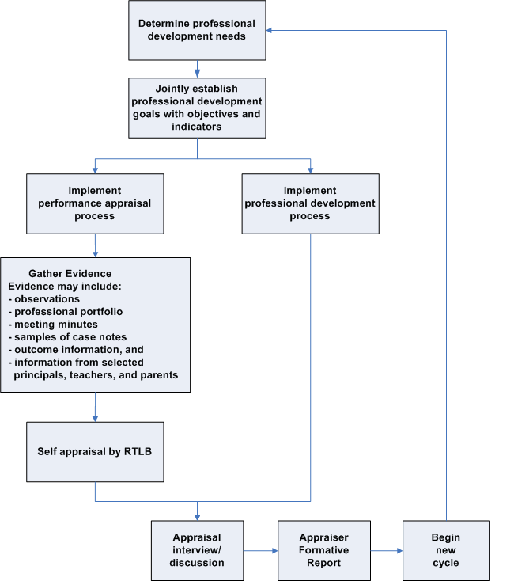

RTLB Professional Standards Overview

Introduction | The RTLB Professional Standards describe the expected standard of performance for RTLB.  While the Professional Standards are not part of the teachers' collective employment agreements, they may be used as a basis for the appraisal.

Components of RTLB Professional Standards | The RTLB Professional Standards are not (at February 2007) part of the teachers' collective agreements. They were developed after consulting a wide group of education sector representatives. These standards are designed to be a useful tool in the performance management cycle.  The RLTB Professional Standards are categorised, and more details is referenced, in the following table.
  Topic | See Page
  1. Professional Knowledge Standard | 52
  2. Professional Leadership Standard | 53
  3. Professional Development Standard | 54
  4. Te Reo Me Ona Tikanga Standard | 55
  5. Teaching Techniques Standard | 56
  6. Staff and Student Management Standard | 57
  7. Relationship Management Standard | 58
  8. Programme Management Standard | 59

1. Professional Knowledge Standard

Professional standard | For the professional knowledge standard, the RTLB will be able to demonstrate a significant depth of knowledge in the theory and practical application of:  - a range of inclusive strategies based on effective practice  - learning and assessment theory  - the current issues and initiatives in education, including Māori education.

Performance indicators | The RLTB needs to show evidence of:  - documenting, in a timely and appropriate way, case management and the advice that has helped keep students in classrooms and schools  - collecting data to support practice and advice  - applying current theory and practice in Māori education  - participating in staff professional development that promotes consideration of emerging educational thinking and practices  - identifying, implementing and evaluating a range of educational and management approaches to meet students', teachers' and school needs.

2. Professional Leadership Standard

Professional standard | For the professional leadership standard, the RTLB will be able to demonstrate a high level of effectiveness in:  - encouraging positive schoolwide engagement in learning  - fostering and practising cultures of learning and achievement  - a wide range of techniques that motivate a diversity of students to improve their educational outcomes  - assisting teachers to create a positive environment in which students make changes in, and take responsibility for, their learning or behaviour.

Performance indicators | The RLTB needs to show evidence of:  - facilitating staff development workshops and meetings  - providing in-service training for teaching and support staff  - providing constructive feedback to schools  - having frequent and wide-ranging interactions with staff  - working in a variety of ways with staff  - providing evaluative feedback for development purposes  - working in a leadership role  - supporting colleagues in changing their practice through consultation and collaboration  - contributing to professional debates both internal and external to the school  - considering appropriate examples for RTLB working with Māori students.

3. Professional Development Standard

Professional standard | For the professional development standard, the RTLB will be able to demonstrate a high level of commitment to:  - further developing personal knowledge and skills  - encouraging and assisting staff in professional development  - further developing understanding of the Treaty of Waitangi  - completion of specialist training for resource teachers (ie Diploma for Special Needs Resource Teacher or its equivalent)  - further developing their knowledge and understanding of the New Zealand curriculum  - self-reflection and participation in professional supervision and support groups on the effectiveness of programmes and interventions  - acquiring new knowledge and skills, and improving personal capability and effectiveness.

Performance indicators | The RLTB needs to be able to show evidence of:  - attending appropriate seminars, courses, workshops or conferences  - networking and liaising with other relevant agencies  - committing to tertiary or other work-related studies  - identifying, locating or providing appropriate resources  - assisting with staff professional development  - participating in activities that enhance the understanding of Treaty of Waitangi issues  - contributing to the review, evaluation and development of school curricula  - participating in support groups or peer review processes  - identifying personal development needs and appropriate development activities  - communicating personal and professional needs to the appraiser when establishing performance expectations.

4. Te Reo Me Ona Tikanga Standard

Professional standard | For the te reo me ona tikanga standard, the RTLB will be able to demonstrate commitment to the promotion in education of:  - the appropriate and accurate use of te reo Māori  - the acknowledgement and promotion of iwi protocols  - a commitment to the Treaty of Waitangi and its principles of partnership, protection, and participation  - sensitivity to meeting the needs of Māori students and providing services that are culturally appropriate.

Performance indicators | The RLTB needs to be able to show evidence of:  - pronouncing and using Māori names and words correctly  - participating in Māori cultural settings and developing an understanding of iwi protocols  - using interventions and strategies that reflect an awareness of the Treaty (eg using a consensus approach to decision making)  - working with Māori agencies in appropriate ways (eg Resource Teachers Māori, Nga Pouwhakataki).

5. Teaching Techniques Standard

Professional standard | For the teaching techniques standard, the RTLB will be able to demonstrate highly developed teaching strategies and expertise in supporting staff in the development and practice of:  - inclusive teaching programmes  - effective programme implementation  - assessment of learning and behaviour  - staff support and advice  - monitoring programme outcomes  - assisting teachers to adapt classroom programmes and environments so they cater for a diversity of student needs.

Performance indicators | The RLTB needs to be able to show evidence of:  - planning and implementation of inclusive programmes  - modelling effective practice  - collecting appropriate data for accepted referrals  - providing pre-intervention and post-intervention data that demonstrates the effectiveness of teaching techniques  - documenting staff interactions regularly, both formally and informally (eg in case notes, case conference notes)  - initiating and participating in the development of teaching resources, strategies and techniques  - providing resources for reinforcing teaching and student management strategies  - adapting programmes and curriculum at a range of school levels  - making changes to the environment to cater for diversity.

6. Staff and Student Management Standard

Professional standard | For the staff and student management standard, the RTLB will be able to demonstrate expertise and highly developed strategies in:  - identifying and facilitating change in school systems to influence student learning and behaviour  - acting as a source of information regarding referrals of students with learning or behaviour difficulties  - appropriately referring students to specialist agencies  - supporting policy and programme development that reflects the changing school community's social and cultural environment  - advocating for students.

Performance indicators | The RLTB will be able to show evidence of:  - participating in the processes that lead to informed changes in school management practices  - providing appropriate advice  - liaising successfully with external agencies  - using support from community-based agencies  - planning and developing programmes that exhibit social and cultural relevance  - contributing actively to the continuing development of support systems for students at risk  - assessing risks to students' physical, cultural and emotional safety and consulting on appropriate actions.

7. Relationship Management Standard

Professional standard | For the relationship management standard, within an inclusive model, the RTLB will demonstrate:  - a high level of Interpersonal communication skills  - consultation, collaboration, facilitation, and reflective practice skills  - cultural sensitivity and an understanding of the Treaty of Waitangi  - responsiveness.

Performance indicators | The RLTB will be able to show evidence of:  - developing and maintaining positive working relationships  - working in a collaborative, consultative model.  - using appropriate skills, techniques and resources across a range of interactions to model desired behaviour.  - facilitating group conferences successfully.  - providing constructive feedback.  - interacting appropriately with Māori in a range of settings  - responding flexibly to needs  - seeking advice and guidance when needed  - working toward mutual trust and guidance  - focusing on problem solving  - initiating and participating in the development of teaching resources, strategies and techniques  - effectively managing positive relationships  - working at different levels within the compulsory school sector  - reinforcing close working relationships between schools and parents, caregivers, families and whānau.

8. Programme Management Standard

Professional standard | For the programme management standard, the RTLB will be able to demonstrate expertise and highly developed strategies in developing, delivering, monitoring, and evaluating operational processes.

Performance indicators | The RLTB will be able to show evidence of:  - following cluster referral processes and policies for case management and using clearly structured timelines  - convening scheduled meetings that follow the consultative and collaborative process  - collecting, analysing, and using data as the foundation for interventions  - adhering to privacy and confidentiality requirements  - consulting with appropriate groups and individuals  - providing continuing monitoring and support  - being aware of management processes and structures within cluster schools and dealing with them appropriately  - providing regular updates, reviews, and reports to appropriate parties  - coordinating services effectively  - applying appropriate concepts and theories to issues or problems  - using a range of investigative techniques to seek relevant information.

Chapter 6:
Funding and Administration

Overview

Before you begin | Ensure you are familiar with Part 1, Chapter 2 RTLB Policy on page 9.

In this chapter | This chapter contains the following topics:
  Topic | See Page
  Manage Funding | 61
  Grants and Allowances | 62
  Travel Management | 64
  Sick Leave Reliever Funding | 66
  Learning Support Funding | 67

Manage Funding

Responsibility of fund-holder school | To manage RTLB funds, the fund-holder school needs to ensure it fulfils the responsibilities listed below.  - Receive cluster funding from the Ministry on behalf of cluster schools.  - Manage cluster funding, in accordance with Ministry RTLB policy and the cluster's financial policies.  - Comply with Ministry RTLB policy on the equitable allocation of Learning Support Funding (refer to page 67) and year 11–13 Funding (refer to page 68) for the target group of students. That is, those at risk of underachieving owing to learning or behaviour difficulties.  - Ensure that all funds received on behalf of the cluster are separately identified in the cluster operational accounts.  - Identify and carrying forward any unspent cluster funds for use by the cluster in the following school year. Minutes must be kept for arrangements of this nature.  - Report regularly to cluster schools on the use of cluster funds, including a written annual report.  - Include RTLB funding in the school's annual financial statements.  - Ensure appropriate auditing processes are in place.  - Send a summary of the cluster's financial position annually to the Ministry, using the template supplied in the annual report form. The annual report form template is on www.tki.org.nz/r/governance/rtlb/  Note: The fund-holder school may not retain any unspent cluster funds or staffing allocation for its own use.

Funding Staffing and Allowances Handbook | The Funding, Staffing and Allowances Handbook contains information about RTLB staffing and funding.  This handbook is available at www.minedu.govt.nz/goto/resourcinghandbook

Grants and Allowances

Introduction | Grants and allowances consist of:  - an establishment grant  - an administration grant  - management time allowance  - travel and study grants.  These grants and allowances are described in this topic.

Establishment grant | Each new RTLB position attracts a one-off establishment grant of $2,000 towards set-up costs. Clusters that move RTLB positions from one school to another do not attract further establishment grant funding. Resources and office equipment purchased with this grant should be transferred between the schools concerned.

Administration grant | The administration grant is paid at a Ministry-determined rate per RTLB position per year. This grant is to assist the cluster with meeting the costs of administering the RTLB, for example, office cleaning, telephone and fax lines, laptops, cell phones, and continuing professional development costs.  Note: The Ministry expects that every RTLB will have a laptop, usually through the Laptops for Teachers' Scheme (TELA).

Administration costs not covered | The cluster is not expected to cover heating, lighting, or water costs for RTLB offices. This is because such funding is included in the employer school's operational funding.  Employer schools should not:  - charge any form of 'rental' to clusters for RTLB offices  - use funds for additional salary units to pay employer school staff for RTLB management, without the prior approval of the cluster governance group.  Employer schools seeking additional funding for heating, lighting and water should refer to the Funding, Staffing and Allowances Handbook which is available at www.minedu.govt.nz/goto/resourcinghandbook

Textbooks | When an RTLB is in training, the cluster should set aside funds to purchase textbooks. These textbooks become a cluster resource. RTLB may wish, but should not be expected, to purchase personal copies of textbooks.
Continued on next page
Grants and Allowances, Continued

Management time allowance | Each RTLB position generates a 0.05 FTE management time for the employer school. This recognises the additional responsibility associated with managing RTLB. The management time allowance is an additional staffing allowance and is shown separately on the school's staffing entitlement notice.  Note: If there are several employer schools in a cluster, this allowance may be transferred to a single employing school as an aggregated resource for supporting RTLB management more efficiently. Some clusters contract a person to manage their RTLB using this time allowance.

Travel and study grants | There are four Ministry funding rates for travel. Every RTLB position attracts at least the minimum level of travel funding per year. Grants at the other three funding rates are allocated by taking into account the geography, size and number of schools within the cluster. Each cluster manages its own travel grant.  The Ministry also pays a study grant for travel and accommodation direct to the each cluster’s fund-holder school in July each year. This is to support RTLB training: the cluster meets the study-related travel and accommodation expenses incurred during the year as required.

Travel Management

Travel reimbursement | Travel reimbursement rates are specified in the teachers' collective agreements. The rates are intended to cover all travel costs, including the RTLB’s insurance.  When boards reimburse own-car travel, they must use the mileage rate stated in their collective agreement. Collective agreements are 'actual rate' documents in terms of Section 75 of the State Sector Act 1988. For more detail, refer to the Funding, Staffing and Allowances Handbook, which is available at www.minedu.govt.nz/goto/resourcinghandbook

Leasing cars | Clusters may lease cars to reduce the wear and tear on personal vehicles or to make the most efficient use of the funding.

Additional travel funding | If a cluster needs more travel funding, it can apply to the local or regional office of the Ministry of Education.  Applications must be made on the Resource Teacher Travel Grant Application form located at www.minedu.govt.nz/goto/resourcingforms and have the following documents attached.  - A letter from the management committee requesting the change.  - A copy of the cluster's travel policy. The cluster must provide proof that it is making the most efficient use of the funding it has, including whether or not leased or rental vehicles are being used, and the per-kilometre rate paid to individual teachers.  - Evidence of the travel mileage and expenditure (GST inclusive) for the previous year and current year to date for each RTLB position in the cluster.  - A map showing the location of the cluster's schools.  The Ministry will determine if one or more of the following applies before allocating more travel funding.  - The cluster has exceeded (or predicts it will exceed) the total cluster RTLB annual travel grant and has already used any unexpended travel grants from the previous year(s).  - The special training grant and cluster travel grant together prove insufficient to meet costs associated with the mandatory university study course.
Continued on next page
Travel Management, Continued

Insurance for cars | Many insurance companies will not accept claims under personal insurance policies because the car is being used as a 'tool of trade'. The cluster needs to discuss this with the RTLB to ensure the vehicle is covered in the event of an accident.

Sick Leave Reliever Funding

Introduction | As RTLB are in itinerant positions, the Ministry expects that when a relief teacher is required the cluster will endeavour to employ a suitably trained and qualified teacher.

Reimbursements | The Ministry will reimburse the cost of a relief teacher when an RTLB is on sick leave if the absence is for more than eight days.  Reimbursement for sick leave is not available for relievers to cover teachers who are employed from cluster funding. This includes Learning Support Funding (LSF) and year 11–13 Funding.  For more detail, refer to the Funding, Staffing and Allowances Handbook, which is available at www.minedu.govt.nz/goto/resourcinghandbook

Learning Support Funding

Introduction | Learning Support Funding (LSF) is allocated, according to cluster policy, to support students who have learning or behaviour difficulties and to support the work of RTLB.

Basis for LSF amount | The LSF amount allocated per cluster is based on the roll and decile of schools. The ratio is the same as the one used for determining the number of RTLB in each cluster and is reviewed annually based on the 1 July roll return.

Management of LSF | Clusters receive LSF as a lump sum. This is to retain flexibility and give clusters the opportunity to use the grant innovatively and equitably.  Funding should be accessed by the cluster's schools on a needs basis, not on a pro rata basis to schools.  If RTLB Māori work in more than one cluster, consideration will need to be given to ensure that some LSF is available to support the target students.

Applying for LSF | Each cluster must have a process for schools, based on student needs, to apply for LSF. It should not be distributed on a pro rata basis to schools. Use of LSF should be reported to the cluster and the Ministry. An example of an application form is available in the Templates document and from www.tki.org.nz/r/governance/rtlb/.

Restrict to RTLB roll | LSF should be restricted to providing support for students who are, or who have been, on an RTLB roll or to projects that will lead to improved outcomes for those students.
Continued on next page
Learning Support Funding, Continued

Examples of use of funding | Examples of cluster use of LSF include:  - providing release time for classroom teachers to meet with RTLB or prepare Individual Education Programmes (IEPs)  - providing individual support to students on RTLB rolls or following RTLB intervention  - employing part-time teacher/s to support learning programmes (these teachers should not be called RTLB)  - purchasing cluster resources to which all schools have access  - allocating teacher aides to particular students or programmes with specific goals  - supporting schoolwide or syndicate programmes for students with learning or behaviour difficulties  - employing cluster teacher aides to work among cluster schools as required  - using the funding as a basis for cluster resourcing of special projects.

Year 11–13 funding | RTLB support students in years 0–10. Support for older students is provided through the year 11–13 Funding. The amount of this funding per cluster is based on the year 11–13 roll and the deciles of cluster schools. It is provided to clusters rather than direct to schools to encourage creative and flexible use of the amalgamated sum.  Schools receiving year 11–13 funding must report to the fund-holder school on the use of this funding, so that this information can be included in reports to cluster schools and the Ministry.  Many clusters use this year 11–13 funding to employ full or part-time teachers who work in a similar way to RTLB, but who are dedicated to the older student group. These teachers are not RTLB.  The Ministry does not fund RTLB training for cluster-employed year11–13 teachers. However, clusters may fund these teachers to join RTLB training courses.  Note: Care should be taken to ensure that year 11–13 cluster-funded teachers are not confused with RTLB when notifying Education Services Payroll or providing the Ministry with any statistical returns. Such teachers do not attract administration or travel grants.

Chapter 7:
Planning and Reporting

Overview

Before you begin | Ensure you are familiar with Part 1, Chapter 2 RTLB Policy on page 10.

In this chapter | This chapter contains the following topics:
  Topic | See Page
  Planning and Reporting Cycle | 71
  Record Keeping and Reporting | 73

Planning and Reporting Cycle

Introduction | Every cluster should have a continuing and regular annual planning, self-review and reporting cycle that leads to improvement.  This should involve all key stakeholders and take into account:  - cluster schools' strategic plans  - processes and outcomes for students (qualitative and quantitative data)  - feedback from RTLB, teachers, principals, parents, whānau and students  - review of current policies, procedures and practice  - future practice, resourcing decisions, processes and approaches.

Cluster planning and reporting cycle | The diagram below summarises the steps in the cluster planning and reporting cycle.  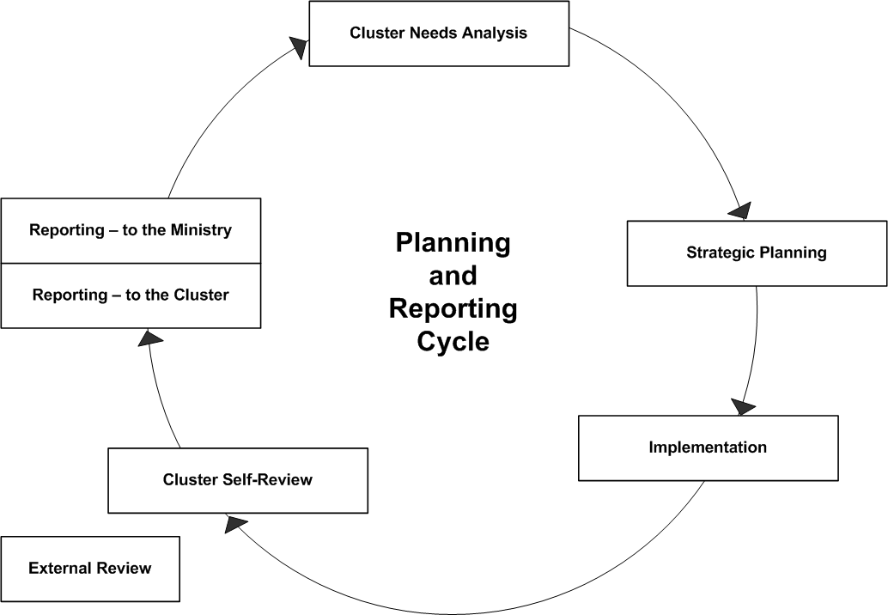  The remainder of this topic provides more detail about the needs analysis, planning, implementation and review steps. Reporting is covered in the next topic on page 73.
Continued on next page
Planning and Reporting Cycle, Continued

Cluster needs analysis | A starting point for cluster planning is a cluster needs analysis.  This should involve:  - analysis of referral trends and patterns  - focus on the impact of particular RTLB interventions on student achievement  - emerging needs in cluster schools in relation to students at risk of underachieving owing to learning or behavioural difficulties.  A cluster may want to take an overview of its operations, or focus on a particular aspect each year. The information gathered during this process will inform future planning for the cluster.

Strategic planning | Strategic planning should include cluster:  - vision – the ideal outcome of cluster efforts  - mission – what the RTLB role is  - goal development – how the cluster meets the identified needs  - action plans – specific objectives, tasks, roles, responsibilities, timelines, and achievement indicators.

Implementation | This relates to implementation of defined:  - tasks  - roles  - responsibilities  - timelines  - achievement indicators.

Review | Review consists of self-review by the cluster and external review.  Cluster self-review should include:  - reflect on governance, management and practice  - review strategic planning goals  - ask: What is working? Why? How do we know?  - ask: What hasn't worked? What are the restraints?  - ask: What outcomes have been achieved?  - ask: What are the continuing needs?

Record Keeping and Reporting

Record keeping | Every cluster plans annually to meet the needs of the target students, including those in Māori-medium settings. Employing principals ensure that the RTLB they employ keep a record of work undertaken and of outcomes for students.  RTLB need to gather sufficient evidence to demonstrate the effectiveness of their interventions. They collect, analyse and use data during their involvement with a student or a group of students and their teachers, in relation to mutually agreed goals.

Cluster reporting | At cluster level, the records of individual RTLB are collated into a cluster record.  Using this information, the management committee reports on the work of its RTLB and the outcomes of students, to the governance group that is responsible for reporting to each school and to the Ministry.

Reporting to schools | Each clusters will determine its own style of reporting to schools, but the following elements should be included:  - the management of the cluster  - identified trends and patterns  - the impact of RTLB work on student achievement (learning and behaviour outcomes).

Reporting to Ministry of Education | Reporting to the Ministry is in a prescribed format that is set out in the RTLB Annual Report Form.  The RTLB information for the report should be completed by the end of term four each year. The full report is due with the Ministry by the end of May the following year, so that cluster reporting aligns with the school planning and reporting cycle.

Chapter 8:
Professional Practice

Overview

Introduction | This chapter contains elements of good RTLB practice, and support for RTLB professional practice. Resources to supplement the Toolkit will be placed on www.tki.org.nz/r/governance/rtlb/ over time.

In this chapter | This chapter contains the following topics:
  Topic | See Page
  Professional Practice Overview | 75
  Support | 77
  RTLB/GSE Interface | 78
  Professional Supervision | 79
  NZRTLBA and Learning Support Networks | 81
  Induction and Coaching | 82
  Te Kete Ipurangi and Reading and Research | 83
  RTLB Qualification | 85
  Communities of Practice | 88
  Conference and Hui | 89
  In-service Teacher Education Practice (INSTEP) | 90

Professional Practice Overview

The professional practice model | The diagram below represents the professional practice model.  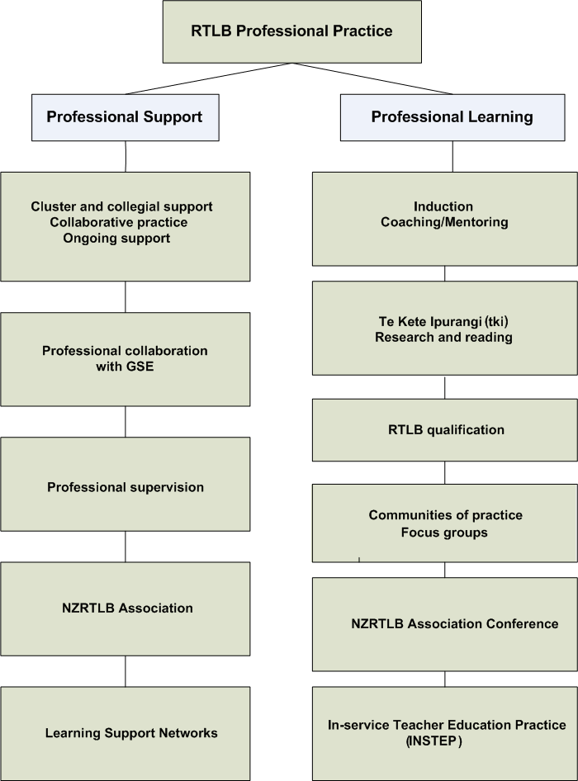

Where to from here | The following topics provide detail about each component of the professional practice model.

Support

Context | Support relates to the first box under Professional Support in the RTLB Professional Practice model on page 75.  Support consists of:  - cluster and collegial support  - continuing collaboration and RTLB support.

Management and cluster support | The support of principals and others in management positions within schools is critical to the work of RTLB.  Effective support requires a good understanding by principals and teachers of the model that RTLB use.

Collaborative support | Many of the issues teachers and schools face regularly cannot be resolved easily, or on their own. RTLB need to be part of the schools they work in. They are a resource for schools and provide continuing support to the teachers in a collegial manner.

RTLB/GSE Interface

Context | The RTLB/GSE interface is the second box under Professional Support in the RTLB Professional Practice model on page 75.

Introduction | To ensure a seamless provision of service to schools, RTLB and Ministry of Education Special Education (GSE) staff must work in partnership. This partnership must be from referral onwards, to provide appropriate support for identified students.  Clusters must have a protocol with GSE showing the ways in which RTLB and GSE work together (refer to page 96 for more information).

How interface should work | Networking between RTLB and GSE should include:  - liaison  - referral systems  - support by GSE for some RTLB work  - co-working  - professional development  - use of resources.

Benefits of working together | Quality networking between RTLB and GSE will provide the following benefits:  - effective coordination of RTLB and GSE  - reduction or minimisation of overlap or gaps in service provision  - better outcomes for students  - mutual understanding of respective roles  - smooth transitions for students from one service to the other and between educational settings.

Professional Supervision

Context | Professional supervision is the third box under Professional Support in the RTLB Professional Practice model on page 75.

Supervision framework | Professional supervision of RTLB is based on the following approach from the National Supervision Framework, Ministry of Education (2005):  'Formal supervision is a structured, safe and reciprocal relationship for reflecting upon practice. The process supports, challenges and inspires us to deliver a responsive and effective service for clients. Formal supervision is based on our collective strengths and an intention to achieve professional, personal and service objectives in the interests of our clients. Supervision acknowledges different views of knowledge and ways of knowing, including those of Māori and other cultures.'

Supervision is for all RTLB | All RTLB should have access to and participate in continuous professional supervision. Professional supervision is essential when RTLB are dealing with complex learning and behaviour issues.  Professional supervision guides and facilitates the RTLB into developing, achieving and sustaining high quality practice. It leads to professional growth and improved outcomes for students, schools and teachers.

Funding | Professional supervision should be funded from the RTLB administration grant.

Appointing a supervisor | A suitable supervisor must be appointed and a supervision contract drawn up. The professional supervision contract template is available from Templates document and from www.tki.org.nz/r/governance/rtlb/.

Guidelines for supervisors | The supervisor should:  - follow an agreed process  - understand the RTLB role  - understand the New Zealand school context and curriculum  - understand effective RTLB practice  - be up-to-date with current evidence-based educational practices  - be trustworthy and empathetic  - be ethical and professional  - acknowledge success  - provide an environment within which practice may be challenged, developed and improved.
Continued on next page
Professional Supervision, Continued

Supervision is effective when… | Formal professional supervision is most effective when it:  - is driven by the practitioner and embedded in RTLB practice  - supports and enhances inclusive practices  - follows the collaborative problem-solving model  - uses practices that are culturally safe  - makes decisions based on evidence  - follows supervision guidelines  - identifies professional development needs  - enhances practice through personal reflection  - addresses ethical dilemmas or unsafe practices  - celebrates success.

NZRTLBA and Learning Support Networks

Context | NZRTLBA and learning support networks are the final components of Professional Support, as shown in the RTLB Professional Practice model on page 75.

NZRLTB | The New Zealand Resource Teacher: Learning and Behaviour (NZRLTB) Association was established in 1999.  The NZRLTB association organises regular regional workshops and forums as professional support for its members. Regions take turns at hosting an annual conference that provides professional learning for RTLB.

Learning support networks | Some clusters are participating in the development of Learning Support Networks.  Each Learning Support Network develops agreements, processes and work programmes that achieve articulated goals that could not be achieved independently.

Induction and Coaching

Context | Induction and Coaching is the first box under Professional Learning in the RTLB Professional Practice model on page 75.

Induction | All RTLB should participate in an induction process to gain a better understanding of their role and the operation of their cluster.  For more information, refer to the Professional Learning and Induction topic on page 43 of Chapter 4: Staff Management.

Coaching/ Mentoring | Many RTLB, especially when new to the position, may benefit from having the direct support of another professional who understands their practice.  There may be times when another RTLB or other professional such as a GSE specialist could act in a coaching role.  Coaching is particularly useful in honing a specific skill or technique to enhance professional practice.

Te Kete Ipurangi and Reading and Research

Context | Te Kete Ipurangi and reading and research is the second box under Professional Learning in the RTLB Professional Practice model on page 75.

Te Kete Ipurangi website | The Te Kete Ipurangi (TKI) website www.tki.org.nz/r/governance/rtlb/ is the repository of the RTLB Policy and Toolkit. Templates to support the RTLB Policy and Toolkit are also on this website.  As Ministry of Education resources and exemplars are developed to support RTLB and clusters, they are added to the site and an email is sent to all principals and RTLB. A quality assurance process has been developed to ensure the standard of the resources.

Research | RTLB must keep up-to-date with current evidence-based effective practice through quality professional reading.  Suitable readings may be shared at focus group meetings or regional workshops.  Some RTLB undertake action research aligned to their professional work. Care should be taken to use ethical research processes. RTLB may choose to offer their research to others for inclusion on the TKI website for sharing with other teachers.

Useful articles | Possible sources of useful articles are:  - Kairaranga (NZRTLB Association and GSE)  - NEWSLETTERS (NZRTLB Association)  - SET (NZCER)  - RTLB website on TKI  - Curricula and other documents (Ministry of Education)  - University libraries.

Tips for research | The following paradigm* may be helpful when studying or undertaking research:  * Adapted from 'What works for children? Barriers and enablers to using research evidence in practice.' Kristen Liabo, City University, London, and presented at the 'What works?' The Social Policy, Research and Evaluation Conference, Wellington, 2004
  ACQUIRE  Finding relevant research  Knowing where to look | ASSESS  Deciding on the quality and  relevance of the research
  ADAPT  Deciding which components of a study are replicable in my work  as an RTLB | APPLY  Implementing research in  practice as far as possible

RTLB Qualification

Context | RTLB Qualification is the third box under Professional Learning in the RTLB Professional Practice model on page 75.

Training programme consists of four courses | An RTLB must attain the RTLB Qualification within three years of appointment, by completing the RTLB training programme.  The RTLB training programme, as at February 2007, comprises four courses:  1. context of the individual child  2. classroom context  3. context of the school and community  4. professional practice portfolio.

Programme duration and makeup | The training programme lasts two years. It includes a combination of block courses in regional centres, tutorial group sessions and online access to resource materials.  The courses are focused on the professional development of RTLB in the clusters in which they work.  All course assessment is designed around the RTLB’s continuing professional practice.

Exemptions and recognition of prior learning | RTLB may undertake their university studies at either postgraduate or graduate diploma level depending on their prior academic qualifications.  Graduates undertaking the postgraduate diploma take all four papers at master’s level.  Non-graduates, in taking the graduate diploma, may take the first two papers at undergraduate level and the second two at master’s level.  There will be no exemptions from RTLB training.  However, RTLB with relevant qualifications may be given permission to do alternative assignments in recognition of prior learning. This is at the discretion of the training provider and in accordance with the relevant university's own protocols.
Continued on next page
RTLB Qualification, Continued

Programme principles and perspectives | The four courses in the RTLB training programme are designed to incorporate the following principles and perspectives:  - an ecological, educational model  - an inclusive teaching approach  - Te Ao Māori (a Māori world view)  - bicultural and multicultural partnerships  - data-based decision making  - reflective evidence-based practice  - consultative, collaborative problem-solving skills for working with school leaders, class teachers and parents, families/whānau and students.

Theory and research basis | The RTLB training programme critically examines both the theoretical foundations and practical applications of ways to support students with additional needs in mainstream education.  This includes a critical analysis of a range of issues. For example, classroom ecology, community partnerships, effective schools, strategies for successful academic achievement, and the analysis and management of behaviour difficulties.  The programme introduces RTLB to a range of thoroughly-researched teaching and learning strategies. Particular care is taken to ensure all elements of the courses are based on a sound empirical and theoretical foundation.

Study leave and workload | Each cluster management committee is expected to support its RTLB by reducing their workload during the two-year training period. University assignments require the RTLB to undertake specific case studies and tasks, and the management committee must consider these. While they are in training, RTLB are entitled to a half-day per week equivalent study leave during the university semester. All RTLB in training must be released for university block courses and be given their study leave entitlement.

Deferment of training | Changing circumstances may mean that an RTLB will need to defer the training. Approval to defer training is given by the employing principal and the cluster management committee. The employing principal should advise the Ministry and training provider accordingly.  Note: A deferment could have financial implications for the cluster, as the course may not be available locally the following year, and the RTLB may have to travel further to attend courses.
Continued on next page
RTLB Qualification, Continued

Travel and accommodation | RTLB must be reimbursed for travel and accommodation expenses by the cluster at their respective collective agreement rates.  Clusters with RTLB who are required to travel to and from outside venues for training should investigate the most cost-effective travel arrangements.  RTLB who are in training and are required to travel more than 100 kilometres to an outside venue are allocated a special study grant by the Ministry. This is to assist with associated travel and accommodation costs.

Failure to pass or to complete | Each paper builds on the one preceding it. If a paper is not passed or not completed the first time, it must be repeated at the student's or cluster's expense.  Any difficulties with courses should be discussed at as early a stage as possible with the appropriate university.

Communities of Practice

Context | Communities of Practice is the fourth box under Professional Learning in the RTLB Professional Practice model on page 75.

What are communities of practice? | Communities of practice are face-to-face or online forums that:  - are valuable for fostering continuing evidence-based professional learning that is relevant to current practice  - are professional learning communities of appropriate professionals, including RTLB, who meet regularly  - focus on the identified professional learning needs of the participants, as determined by performance management and cluster planning cycles  - are forums where readings are shared and debated, and current research is examined for its relevance to the challenges that arise in professional practice.

How to be effective | For communities of practice to be effective, they must have:  - a professional leader/facilitator  - access to professional reading and current research  - time for regular meetings.

Outcomes | Outcomes of communities of practice include:  - RTLB are provided with professional stimulus, critique and support  - current research is examined  - data is shared and debated  - practice is challenged  - resources are shared  - a forum for reflection with peers and new learning  - improvement in practice leads to improved outcomes for students  - student achievement is emphasised  - student achievement information is analysed and discussed  - RTLB practice is examined and critiqued  - learning is informed by evidence  - participation and community building is emphasised.

Conference and Hui

Introduction | Conference and hui relates to the fifth box under Professional Learning in the RTLB Professional Practice model on page 75.

RTLB annual conference | The New Zealand Resource Teacher: Learning and Behaviour (NZRTLB) association organises an annual national conference for RTLB.  The cluster management committee decides which (or all) RTLB will attend.  The committee’s decision should be consistent with decisions on other teachers, principals or deputy/assistant principals seeking similar professional opportunities.  Attendance at conference should be planned as part of the professional development plan for an RTLB.

Hui-a-Tau | Each year the Māori caucus of the NTRTLB Association meets to:  - showcase and share examples of good practice  - maintain a database of projects  - develop or strengthen relationships with iwi and hapū.

In-service Teacher Education Practice (INSTEP)

Context | In-service Teacher Education Practice (INSTEP) is the final component under Professional Learning in the RTLB Professional Practice model on page 75.

What is INSTEP? | In-service Teacher Education Practice (INSTEP) is a research and development project about the learning and practice of advisers, facilitators, resource teachers and other in-service educators. A number of RTLB have been invited to participate in INSTEP.

Objectives of INSTEP | The objectives of INSTEP are to:  - explore and develop effective approaches for the professional learning of in-service teacher educators  - strengthen and promote evidence-based in-service teacher education practice  - support professional leadership and continuing improvement within the  in-service teacher education sector.

Chapter 9:
Service Provision

Overview

Introduction | This chapter describes aspects of delivering RTLB services, that is, how students access services, who is eligible, and how they are referred.  This chapter also covers measuring shifts in learning and behaviour, reporting, conducting safe practice and confidentiality of information.

In this chapter | This chapter contains the following topics:
  Topic | See Page
  Access to Service | 92
  Eligibility for Service | 93
  Referral and Review | 96
  Intervention Sequence | 99
  Recording and Reporting | 100
  Safe Practice | 102
  Confidentiality | 103

Access to Service

Introduction | Each cluster has policies and procedures to ensure equitable access to the RTLB service. These should include transparent intake procedures that ensure equitable and timely responses. All cluster schools should have access to the cluster's policies and operational procedures, including cluster referral processes.

Referrals for RTLB support | Referrals may be made to the RTLB service for individual students, groups of students or whole classes. Teachers may also request assistance for themselves or for schoolwide initiatives, if these referrals are aimed at addressing the needs of targeted students.

Prioritising criteria | When demand for RTLB service exceeds capacity, RTLB and principals together prioritise the referrals.

Long term cases | If work with long-term cases is restricting RTLB capacity to respond to new referrals, clusters may also need to develop exit criteria. Outcomes for students are likely to be better when RTLB are involved at an early stage. This allows preventative strategies to be put in place, before challenging behaviour reaches a crisis point.  Note: It is important that cluster operational policies define how long students will access RTLB support.

RTLB should not provide… | Under Ministry of Education RTLB policy, an RTLB should not:  - teach a particular subject or course  - act as a remedial tutor of students with special needs  - work as a teacher-aide or reliever  - take responsibility for a special class or unit  - carry out routine school duties  - provide a counselling, social work, or truancy service  - assume management responsibility for crisis/traumatic incidents  - make formal diagnoses of disabilities (eg ADHD, dyslexia), or  - report on a teacher's professional abilities or management skills.

Eligibility for Service

State schools | RTLB work with state and state-integrated schools provided the boards of trustees have signed the cluster's memorandum of agreement.

ORRS not eligible | RTLB do not work with students while they are in Ongoing and Reviewable Resourcing Schemes (ORRS).

Severe behaviour service | Students with challenging behaviour may move between RTLB and Ministry of Education Special Education (GSE). Depending on the severity of the behaviour and the capacity of the services, co-working may also be appropriate. Generally GSE staff focus on students with the highest needs while RTLB focus on students with more moderate needs.

Supplementary learning support | Students on the roll of a Learning Support Teacher (LST) may access RTLB services if they have additional learning or behaviour difficulties that are beyond the scope of the classroom teacher and LST.

Speech language therapy | Students on the roll of a speech-language therapist may access RTLB service if they have additional behaviour or learning difficulties that are beyond the scope of the therapy.

Early intervention | RTLB may work alongside early intervention specialist service providers to support the transition of students into school settings.

The Correspond-ence School | RTLB should not assist a student who is enrolled full-time in the Special Needs or Individual Programme sections of The Correspondence School. Students who are dual-enrolled at The Correspondence School may access the RTLB service as required, as long as they meet the priorities established by the cluster referral (intake) and review policy.

Kura kaupapa Māori or Māori-medium classes | If a cluster includes kura kaupapa Māori or has schools with Māori-medium classes, and does not have access to an RTLB Māori, ways for RTLB to assist these schools need to be considered. Some clusters arrange for assistance from an RTLB Māori from another cluster, Resource Teachers Māori, or by others in the education community who are speakers of Māori.

Non-English speaking students (ESOL) | The statements above also apply to schools that have other language immersion programmes. If a student’s only difficulty is an inability to speak English, the RTLB is not directly involved. If an ESOL student also has special education needs, then a referral may be appropriate.
Continued on next page
Eligibility for Service, Continued

Suspended or stood-down students | Students who are suspended remain entitled to an appropriate educational programme. Therefore, assistance should continue for a student who is on an RTLB roll and who is suspended. Usually this would be off the school site.  Before making such a decision, particularly if an RTLB is expected to work outside the school, personal safety factors should be considered, with reference to relevant cluster and employing school policies.  RTLB do not usually accept referrals for, or continue to work with, excluded students. With cluster approval, an RTLB may assist with a previously excluded student's reintegration into the school system.

Independent schools | RTLB work only with students in state and integrated state schools.  Independent schools receive the Private School Subsidy from the Ministry and resourcing for any verified ORRS students.

Referral and Review

Introduction | Effective clusters have a clear structure and process for referrals and review.

Referral and review subcommittee | There should be a referral (or intake) and review subcommittee comprising representatives of RTLB, GSE, and principals. The subcommittee should meet often enough to ensure that referrals are dealt with promptly.  RTLB should not be 'shoulder-tapped' to take referrals. That is, they should not take referrals informally without adhering to the cluster process for referrals and review.

What review does | A review process enables students to be monitored to make sure they are getting the most appropriate support. It also enables students to be discharged from an RTLB roll to allow for new referrals.  Note: There may be a small number of students with continuing needs whom an RTLB may need to retain.

Protocol with GSE | Each RTLB cluster should have a protocol with GSE to ensure collaborative professional practice from referral onwards. RTLB clusters and GSE are expected to work collaboratively to develop protocols for provision that reflect the needs of their communities.

Three models for referral | There are three possible models for referral for learning and behaviour problems:  - joint GSE/RTLB referral  - direct referral, or  - RTLB Initial referral  These are described below.

Joint GSE/RTLB referral | The process for joint GSE/RTLB referral is as follows.  1. Schools make referral on a Joint RTLB and GSE Referral form.  A sample of a joint referral form is available in the Templates document and from www.tki.org.nz/r/governance/rtlb/  2. Representatives of GSE staff and RTLB jointly consider referrals regularly and decide on the most appropriate person (or people, if co-working is necessary) to be the case worker(s).  3. GSE staff and RTLB jointly review student's progress and achievement to ensure appropriate assistance is being provided.
Continued on next page
Referral and Review, Continued

Direct referral | The process for direct referral is as follows.  1. Before making a referral, a school's special needs committee considers where to make the referral. This committee should comprise the:  - Special Education Needs Coordinator (SENCO)  - RTLB  - other relevant staff, and possibly  - GSE.  2. A referral is made direct to the service referral subcommittee. For example, RTLB, GSE, Health or other agency.  3. Student's progress and achievement are reviewed to ensure appropriate assistance is being provided.

RTLB initial referral | The process for RTLB initial referral is as follows.  1. Schools make referrals to the RTLB referral and review subcommittee.  2. RTLB engages with relevant staff and family to identify the type of intervention needed.  3. RTLB provides the intervention, or the school refers the student to GSE (or other appropriate agency).  4. There is no need for a new or separate referral to be made to GSE. The RTLB and GSE case worker collaborate to move the student to GSE, based on the assessment or other data collated by the RTLB.  5. Student's progress and achievement are reviewed to ensure appropriate assistance is being provided.

Managing transitions | As students begin school, move between schools, or between support services, there will be a period of transition. Clusters should develop protocols to manage these transitions.

Intervention Sequence

Introduction | The RTLB model involves the RTLB working through the intervention sequence, the teacher and others intervening for each student referred.

Intervention sequence process | The intervention sequence is:  1. referral  2. initial meeting  3. data gathering  4. analysis  5. goal setting  6. planning  7. implementation  8. monitoring  9. review  10. follow up and reflection.

Recording and Reporting

Introduction | The recording and reporting of outcomes is used for aggregating data across clusters and nationally.

What to record | For each referred student, the RTLB should record:  - the number of goals set  - the type of goals set  - whether the goals were successfully achieved, not achieved, or in progress.

Measuring Shift in Learning and Behaviour | As a result of goals set and strategies implemented, measurable shifts occur and:  - inappropriate student behaviours and ineffective learning practices reduce  - desired student behaviours increase  - student engagement is enhanced  - new skills are learned  - student knowledge increases.  Clusters are required to report to the Ministry of Education on student outcomes.

Gathering evidence of effectiveness | Gathering evidence of the effectiveness of RTLB involvement requires the following.  - Collecting data at least twice (pre-intervention and post-intervention), so that a value-added analysis can be undertaken.  - Determining at the planning stage, the ways in which the intervention will contribute to enhanced classroom practice and improved student outcomes.  - Deciding how these improvements will be measured.
Continued on next page
Recording and Reporting, Continued

Review goals and data | At the review stage, all the team involved with the planning and interventions review the goals and the pre-intervention and post-intervention data.  The team decides whether goals have been met or not, whether the case can be closed, or whether there are continuing issues.  The evidence of student outcomes upon which decisions are made should be recorded in each case file.  Robust evidence is based on assessment data from a range of sources including:  - interviews  - observations  - questionnaires  - work samples  - test scores  - photos/videos  - incident records  - reflective conversations  - student/teacher/parent reporting.

Reporting to the Ministry of Education | Clusters are required to report to the Ministry on student outcomes in the following four outcome domains:  - participation  - social/behavioural  - learning achievement  - teacher/school capability.  For more information, refer to page the Evidence-Based Student Outcomes topic on 19 of Chapter 2: RTLB Policy.

Safe Practice

Introduction | This topic outlines key safe practice points that RTLB need to know.

Suspicion of abuse | The RTLB should know what to look for and what to do if confronted with suspected abuse.  Schools have access to guidelines for referral to Child, Youth and Family (CYF) or the police when there is any suspicion of abuse. Additionally, Breaking the Cycle - The Interagency Protocols (CYF July 1996) is available in all schools.  Any concerns should be referred immediately to the principal of the RTLB employer school and the board of trustees of the student's school.  If a teacher's behaviour appears to threaten a student's safety, the RTLB must inform the school’s principal. If this is difficult, then the RTLB should seek support from the employer school's board of trustees.  It is vital that the RTLB does not do or say anything that may affect subsequent procedures if the student discloses abuse.

Visiting homes | The RTLB should advise the principal of the student's school if home visits are taking place.  If there is any doubt about personal safety, the RTLB should ask a parent or caregiver to meet at a venue other than the home, for example, at school or other neutral location.

Cultural safety and awareness | RTLB must follow culturally safe practices in working with all ethnicities to improve learning and behaviour outcomes.  RTLB should consult and work alongside Māori educational, professional and cultural advisers and adopt a support rather than leadership role.  RTLB should be involved in cluster consultation with Māori. The development of assessment and programme planning will identify the factors that contribute to the success of Māori students and the effectiveness of school programmes.  RTLB may need support in developing cultural awareness.

Confidentiality

Introduction | RTLB should be familiar with and comply with the following regarding the use, disclosure, storage and transfer of information:  - Official Information Act (1982)  - Privacy Act (1993).

Collection and sharing of information | Parents or legal guardians should give their written consent for an RTLB to collect or share personal information with appropriate professionals.  Personal information should be used and disclosed only for the purposes for which it was collected, unless further consent is obtained from the parent or legal guardian.

Records of particular intervention | All records and data are confidential and in most cases will remain with the RTLB and class/subject teacher.  If an RTLB leaves the position, current records are handed over to the management committee.  The Privacy Act (1993) requires that records must be kept for as long as it is necessary for the purpose for which they were collected.

Transfer of information | Further consent should be obtained from the parent or legal guardian before documentation arising from RTLB work to is passed on to another school.

Access to information | A request for information under the Official Information Act (1982) could result in an RTLB having to provide information about a particular intervention. This Act also protects personal privacy.

Acknowledgements

Introduction | The Ministry of Education appreciates the many people and organisations who have contributed to this RTLB Policy and Toolkit.

Acknowledge-ments | The RTLB Policy and Toolkit was published by the Ministry of Education.  Many people outside the Ministry contributed to this document The organisations and groups that were represented on the Sector Reference Group were the:  - New Zealand School Trustees Association  - New Zealand Principals' Federation  - Secondary Principals' Association of New Zealand  - New Zealand Secondary Principals' Council  - Te Akatea  - NZRTLB Association  - New Zealand Educational Institute  - Post-Primary Teachers' Association  - Pasifika community  - Parents.  Organisations listed above also nominated members for the working groups that worked on the detail of sections of the Policy and Toolkit.  Principals, RTLB and other interested people (at more than 40 meetings across New Zealand) discussed the key messages of the policy and procedures, and made a range of recommendations and suggestions.  The national rollout of the RTLB Policy and Toolkit by Ministry staff has been ably supported by panels of principals and RTLB.  The Ministry thanks all of these people for their significant contributions.

